Task 1: See Appendix B; Task 2 Plot: See below

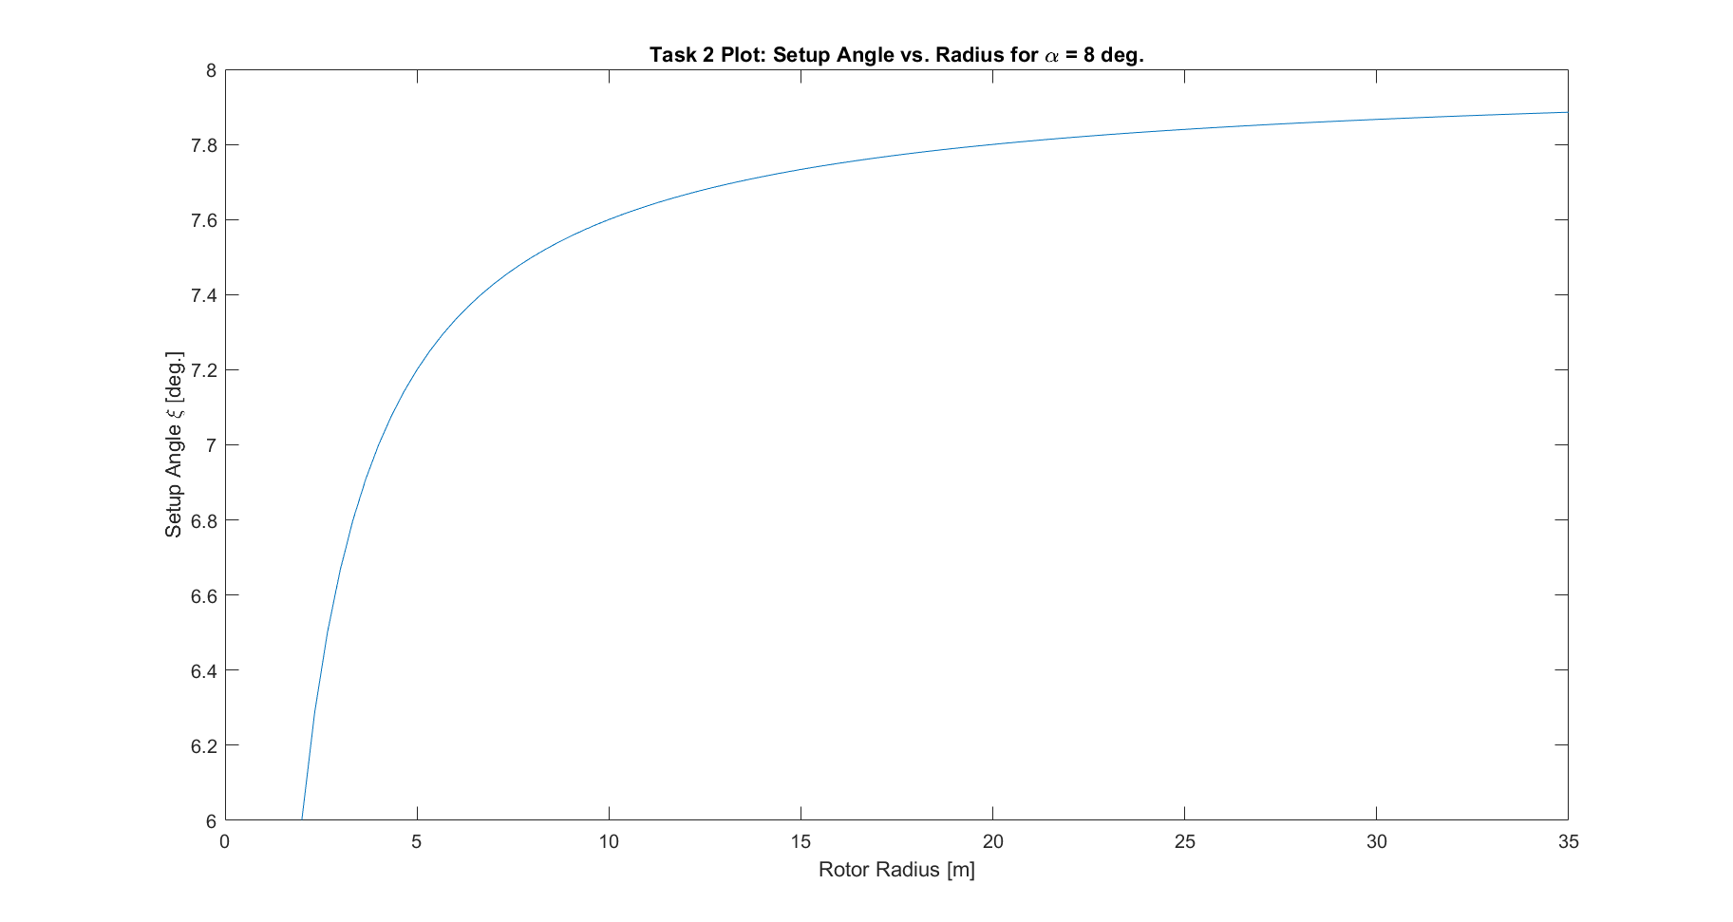Task 3 Plot: m,

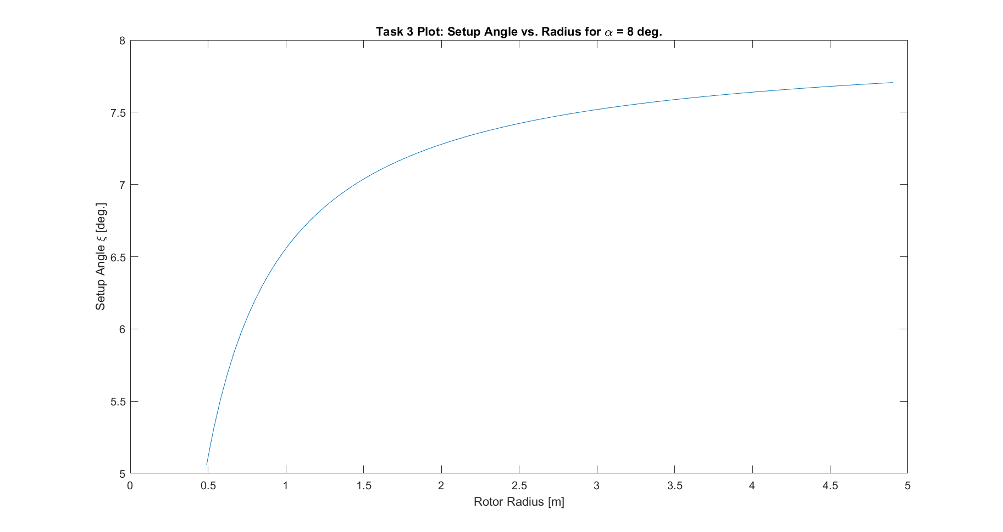

Task 4 Results:

1. Delivered current: IL = 125 A
2. Vcell = 1.48V (recharge, Vin); VL = 0.9765V (discharge, Vout); Vin/Vout = 0.658.

Appendix A: Matlab Code

Task2.m

rau = 1.18  
v1 = 12  
alpha = 8  
CL = 1.27  
n = 3  
K_h = 2.7  
const = 0.4  
r_h = 2  
R = 35  
w = 2  
lamda = w*R/v1  
r_head = r_h/R  
x = const/(1-r_head)  
power1 = (1/3)*n*rau*v1^3*CL*lamda^2*K_h*R  
a = (((1/3)+(const/(1-r_head))*((r_head/3)-1/4))*(1+(4/(9*lamda^2)))^1.5)-(((1/3)+(const/(1-r_head))*((r_head/12)))*(r_head+(4/(9*lamda^2)))^1.5)  
b = x*1/(18*lamda^2)*((sqrt(1+(4/(9*lamda^2)))-(r_head*sqrt(r_head^2+(4/(9*lamda^2))))))  
c = x*2/(81*lamda^4)*log((1+sqrt(1+(4/(9*lamda^2))))/(r_head+sqrt(r_head^2+(4/(9*lamda^2)))))  
ans = power1*(a-b-c)  
Wbetz = 8*pi/27*rau*v1^3*R^2*(1-r_head^2);  
  
eff = (9*n*CL*lamda^2*K_h)*(a-b-c)/(8*pi*R*(1-r_head^2))

Task2Plot.m

%% Task 2 Problem Statement  
  
%% Constants/Initializations  
  
p = 1.18; %[kg/m3]  
v1 = 12; %[m/s]  
a = 8; %[deg]  
CL = 1.27; %unitless, coeff. of lift  
n = 3; %unitless, 3 blades  
Kh = 2.7; %[m], chord at hub r = rh  
o = 0.40; %unitless, taper ratio  
rh = 2.0; %[m], radius at hub  
R = 35.0; %[m], radius at tip  
w = 2.0; %[rad/s], angular rotation speed  
  
lambda = w*R/v1;  
rhat = rh/R;  
  
%% Plot  
  
r = linspace(rh,R,100); %[m], linspace  
w_deg = rad2deg(w);  
zeta = a - atand(2*R*v1./(3*w_deg*R.*r)); %[deg]  
plot(r,zeta);  
xlabel("Rotor Radius [m]");  
ylabel("Setup Angle \xi [deg.]");  
title("Task 2 Plot: Setup Angle vs. Radius for \alpha = 8 deg.");

Task3.m

%% Task 3 Problem Statement  
% Provide 1.5 kW of power. This means Wdot = 1.5e3.  
% Maximize efficiency, Wdot/Wbetz  
  
p = 1.18;  
v1 = 6.5;  
alpha = 8;  
CL = 1.26;  
n = 3;  
w = 3.0;  
  
Wdot_des = 1500;  
ospace = linspace(0,1,101); % Deliverable  
Rspace = linspace(2,190,17001); % Deliverable  
  
% power_results = zeros(31,11);  
% eff_results = zeros(31,11);  
results = [];  
for i = 1:length(ospace)  
 for j = 1:length(Rspace)  
 o = ospace(i);  
 R = 4.904;%Rspace(j);  
 rh = 0.1*R;  
 Kh = 0.085*R;  
 lambda = w*R/v1;  
 rhat = rh/R;  
  
 x = o/(1-rhat);  
 power1 = (1/3)*n*p*v1^3*CL*lambda^2*Kh*R;  
 a = (((1/3)+(o/(1-rhat))*((rhat/3)-1/4))*(1+(4/(9*lambda^2)))^1.5)-(((1/3)+(o/(1-rhat))*((rhat/12)))*(rhat+(4/(9*lambda^2)))^1.5);  
 b = x*1/(18*lambda^2)*((sqrt(1+(4/(9*lambda^2)))-(rhat*sqrt(rhat^2+(4/(9*lambda^2))))));  
 c = x*2/(81*lambda^4)*log((1+sqrt(1+(4/(9*lambda^2))))/(rhat+sqrt(rhat^2+(4/(9*lambda^2)))));  
 Wdot = power1*(a-b-c);  
 Wbetz = 8*pi/27*p*v1^3*R^2*(1-rhat^2);  
  
 eff = (9*n*CL*lambda^2*Kh)*(a-b-c)/(8*pi*R*(1-rhat^2));  
   
 error = abs(Wdot-Wdot_des);  
 if(error < 0.025*Wdot_des) && (eff<1)% && (eff>0.3)  
 col = [o; R; Wdot; eff];  
 results = [results col];  
 end  
 power_results(i,j) = Wdot;  
 eff_results(i,j) = eff;  
 end  
end  
  
power_results = [Rspace; power_results];  
eff_results = [Rspace; eff_results];

Task3Plot.m

%% Task 3 Problem Statement  
% Plot setup angle to keep alpha = 8  
  
%% Constants/Initializations  
  
p = 1.18;  
v1 = 6.5;  
a = 8;  
CL = 1.26;  
n = 3;  
w = 3.0;  
  
% Deliverables  
o = 0;  
R = 4.9042; %[m]  
  
rh = 0.1*R;  
Kh = 0.085*R;  
lambda = w*R/v1;  
rhat = rh/R;  
  
%% Plot  
  
r = linspace(rh,R,100); %[m], linspace  
w_deg = rad2deg(w);  
zeta = a - atand(2*R*v1./(3*w_deg*R.*r)); %[deg]  
plot(r,zeta);  
xlabel("Rotor Radius [m]");  
ylabel("Setup Angle \xi [deg.]");  
title("Task 3 Plot: Setup Angle vs. Radius for \alpha = 8 deg.");

Appendix B: Task 1 Derivation

